SKILL WEEK-1
Task-1:
- To Install Linux VM, Configure GCC, Setup Git Repository, Create Project Structure, Understand Shell Architecture, Build Initial Makefile.

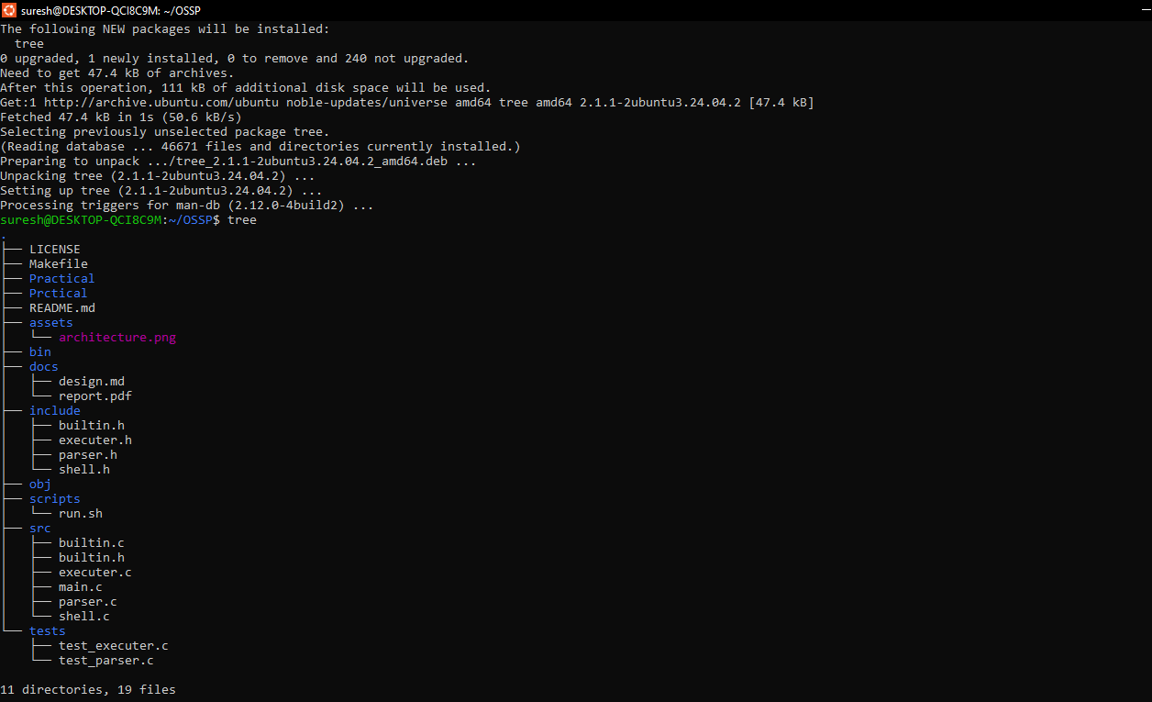
Task-2:
To Analyze process abstraction, execute fork(), understand exec() family, analyze parent-child relationships, inspect process tree, practice system call tracing.
Task-1:
Using a manual command understand the fork() and exec() system calls
Task-2:
Write a C program to create a new process and accepting the user commands using fork() and exec() system calls.

#include <stdio.h>
#include <unistd.h>

int main() {
pid_t pid;

pid = fork(); // Create a new process

if (pid < 0) {
printf("Fork failed!\n");
}
else if (pid == 0) {
// Child Process

printf("This is the Child Process.\n");
printf("Child PID = %d\n", getpid());
}
else {
// Parent Process

printf("This is the Parent Process.\n");
printf("Parent PID = %d\n", getpid());
}
}

